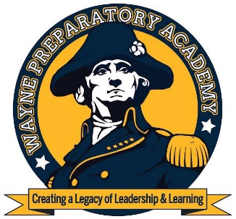
Wayne Preparatory Academy
Creating a Legacy of Leadership and Learning

600 Tommy’s Road
Goldsboro, NC 27530
Info@wpanc.org
919-734-8085

December 5, 2016
Dear Parents/Guardians,

Wayne Preparatory Academy (WPA) is committed to creating unique learning opportunities for our scholars by securing all possible sources of funding. WPA is eligible for Impact Aid funds due to the increased federal presence in our area. To receive these funds, the U.S. department of Education requires us to survey each student to determine eligibility.

Please complete the Impact Aid Survey Form for each child in your household.

-Student Information section: Everyone complete the student information section. If you reside on federal property please name the federal property.

-Parent/Guardian Employment Information: Civilian: Complete this section if you are a civilian who works on federal property. Please provide the complete physical address of your employer on federal property.

-Parent/Guardian Employment Information: Uniformed Services: Complete this section if you are active duty in the uniformed services of the United States.

-Parent/Guardian Employment Information: Foreign Military: Complete this section if you are both an accredited foreign government official and a foreign military officer.

Everyone please sign and date the bottom of the survey form and return to WPA by Friday December 9th, 2016. All information collected is confidential and is used only for the stated purpose. Your cooperation in returning completed forms as soon as possible is greatly appreciated. If you have any questions please feel free to contact Kimberly Court at 919-734-8085 ext. 2.

Sincerely,

Dr. Todd Forgette
Managing Director

